Sunila's annual shutdown - construction site safety document
Table of contents

1. GENERAL INFORMATION AND DESCRIPTION OF STOPPED WORK 3
1.1. Purpose 3
1.2. Description of the shutdown site 3
1.3. The parties to the construction project 3
1.3.1. Sunila the organization of the mill's annual shutdown / Stora Enso Oyj Sunila mill 4
2. CHARACTERISTICS OF THE PROJECT AND DANGERS AND RISKS RELATED TO IMPLEMENTATION OF THE TARGET 4
2.1. Description and location of the construction site and traffic arrangement 4
2.1.1. Site map and safety in case of emergency 4
2.1.2. Instructions for safe passage to the canteen 4
2.1.3. General hazards of the construction site 5
2.1.4. Withdrawals and transfers 6
2.1.5. Fire and explosion hazard 6
2.1.6. Dust, noise, vibration 6
3. SAFETY RULES 7
3.1. Safety objectives 7
3.2. Safety management 7
3.2.1. Shutdown safety control procedure 7
3.2.2. Special focus areas for downtime safety 7
3.2.3. Eight life-saving rules 8
3.3. Subscriber security monitoring 8
3.4. Responsibility when ordering external labor 8
3.5. Operations of the mill and suppliers 9
3.5.1. Responsibilities of suppliers 9
3.5.2. Security planning, which is the responsibility of suppliers 9
3.5.3. Acceptance criteria for the supplier's HSE plan 10
3.5.4. Responsibilities in safety monitoring 10
3.5.5. Meeting practices 11
3.5.6. Staff orientation, qualifications and IDs 11
4. PROCEDURAL INSTRUCTIONS 12
4.1. WORKING 12
4.1.1. Personal protective equipment 12
4.1.2. Noisy work 12
4.1.3. Tools and machines and equipment 12
4.2. CONSTRUCTION AREA 13
4.2.1. Work areas 13
4.2.2. Fire safety and fire works 13
4.2.3. Fire safety equipment disconnection request 14
4.2.4. Jobs with a risk of falling 14
4.2.5. Work with a risk of electrical accidents 15
4.2.6. Preventing the spread of dust 15
5. ACTION IN ACCIDENT AND DANGER SITUATIONS 17
5.1. Making an emergency report 17
5.2. Fire 18
5.3. Property exit alarm 18
5.3.1. Fire alarm button 18
5.3.2. First aid equipment and their location 18
5.4. Hazard communication 18
5.4.1. Protection 19
5.5. General danger sign 20
6. SECURITY SANCTIONS 20
6.1. Procedure for safety deviations at a shutdown site 20
6.2. Sanctions and procedure 20
7. DISCLOSURE 20
7.1. Site communication 20
7.2. Communication of dangerous situations and accidents 21
7.3. Exception communication 21

CHANGE (changes to the instructions written in kenotext) | DATE
Safety document put into use. rev. 1.0 / Timo Kärkkäinen | 23.9.2019
Safety document update rev. 1.1 / Timo Kärkkäinen | 17.1.2020
Safety document update rev. 1.2 / Timo Kärkkäinen | 8.4.2021
Safety document update rev. 1.3 / Timo Kärkkäinen | 18.6.2021
Safety document update rev. 1.4 / Timo Kärkkäinen | 6.7.2022
Safety document update rev. 1.5 / Timo Kärkkäinen | 30.8.2022

- GENERAL INFORMATION AND DESCRIPTION OF STOPPED WORK
  - Purpose
This safety document is a government regulation on the safety of construction work
205/2009 § 8, a safety document drawn up for the planning and preparation of construction work, which contains safety rules and procedural instructions. The safety document explains and presents
The annual shutdown of the Sunila mill about the characteristics, conditions and
danger and harm factors caused by the nature and the risks arising from them.

The safety document contains information and instructions about the project given by the customer, which the main contractor (i.e. Stora Enso Oyj Sunila mill) and suppliers must take into account when planning the construction work, as well as safety obligations and procedural instructions that the contractors and their subcontractors must follow in the works included in the contract.

The safety document outlines the safety rules of the construction site, which must be strictly followed. Sanctions for safety deviations are also described in the document.

Description of the shutdown site
Stora Enso's Sunila mill's annual shutdown site covers the entire Sunila mill.

The main phase of the shutdown is September 19-27, 2022, when the entire Sunila mill will be shut down. The after-work of the shutdown will end when the scaffolding has been dismantled (September 28, 2022 -).

The total number of people estimated for the main phase of the shutdown is about 800 people, and at the same time, about 600 people work at the shutdown site.
Around 200 supplier companies will be affected by the shutdown of the Sunila mill. During the shutdown, the largest works are focused on the following areas:
- Fiber line
- Dryers
- The lye line
Maintenance work is mainly equipment cleaning and pipeline, machine and equipment installations as well as maintenance and repairs. During the annual shutdown, connections and construction work related to the Sunila mill's investment sites are also carried out.

The parties to the construction project
According to Vna 205/2009, Stora Enso Oyj Sunila mill acts as the developer of the construction project, and Stora Enso Oyj Sunila mill acts as the main contractor (the Stora Enso Oyj Sunila mill, which acts as the builder and main contractor, is usually referred to later in the text as mill ).

The mill appoints a safety coordinator before starting work. The safety coordinator cooperates with the mill and suppliers in the construction safety planning and implementation of the construction work. Sunila mill's annual shutdown The occupational safety manager of the Sunila mill acts as the site safety coordinator, who instructs the safety management and supervises the implementation of the safety document.

The representatives of the shutdown organization are responsible for the safety of the annual shutdown site of the Sunila mill.
The production manager acts as the representative of the employer of the organization exercising primary control, and he shares the responsibility of safety coordination with the organization of the annual shutdown of the Sunila mill :
- For operations managers
- For shift foremen
- For the Maintenance Manager, who shares responsibility in his organization:
  - For maintenance managers
  - For maintenance engineers
- For the Technology and Investments Manager, who shares responsibility in his organization:
  - For project managers
  - For project engineers
Organization of the annual shutdown of the Sunila mill are responsible for the safety of the construction site and together take care of the coordination of downtime in the departments under the direction of the operation, maintenance and project managers in their own areas of responsibility.

Suppliers are responsible for their employees by taking care of the safety, competence and safe working practices of their personnel, managing the work, ensuring the professional competence of their employees and participating in the coordination of the work, as well as training the HSE plans and the instructions of the site safety document to their own supervisors and employees, who are also responsible for following the instructions.

Both suppliers and employees of the organization exercising primary control must report potential hazards. Supervisors must ensure the reporting of issues causing danger to the SMART system of the Sunila mill and to the work permit supervisor/issuer of the work permit for the necessary corrective measures, incl. sufficiency of resources, safe execution and coordination of work.

Operation and maintenance supervisors, departmental safety supervisors and suppliers' HSE coordinators/managers participate in the safety rounds and monitoring of the shutdown site.

Stora Enso takes care of the general management of the construction site necessary for safety and health and the organization of cooperation and information flow between the parties, the coordination of activities and the general cleanliness and order of the construction site area in accordance with Vna 205/2009.

Sunila the organization of the mill's annual shutdown / Stora Enso Oyj Sunila mill
- Representative of the employer exercising primary control: Henrik Antila 050-5298390
- Person in charge of the site: Eero Tahvanainen 040-8226335
- Contact person for the builder: Henrik Antila 050-5298390
- Safety Coordinator: Timo Kärkkäinen 040-1867424
- Departments: Stora Enso Oyj Sunila mill organization
- CHARACTERISTICS OF THE PROJECT AND DANGERS AND RISKS RELATED TO IMPLEMENTATION OF THE TARGET

Description and location of the construction site and traffic arrangement
The site area of the Sunila shutdown site includes the entire mill area of the Sunila mill. In the construction site area, work sites are demarcated by fencing to ensure the safety of bystanders. Access to the construction site is carried out through the mill's access control, each with their own personal identifier. As a general rule, the transfer of suppliers from the shutdown site to the site area must take place through pedestrian gates.

If there is a need to use a vehicle on the construction site, for example to transfer/import tools or supplies, the person can be granted a vehicle right of way in accordance with the right of way practice during mill downtime. The downtime site uses the mill's access control system and the related operating model according to the labor notification and access control guidelines.

The construction site area is covered by the camera surveillance of the Sunila mill, there is a separate register statement about the camera surveillance system.

Site map and safety in case of emergency

Sunila mill's safety map, (larger image see Appendix-1).
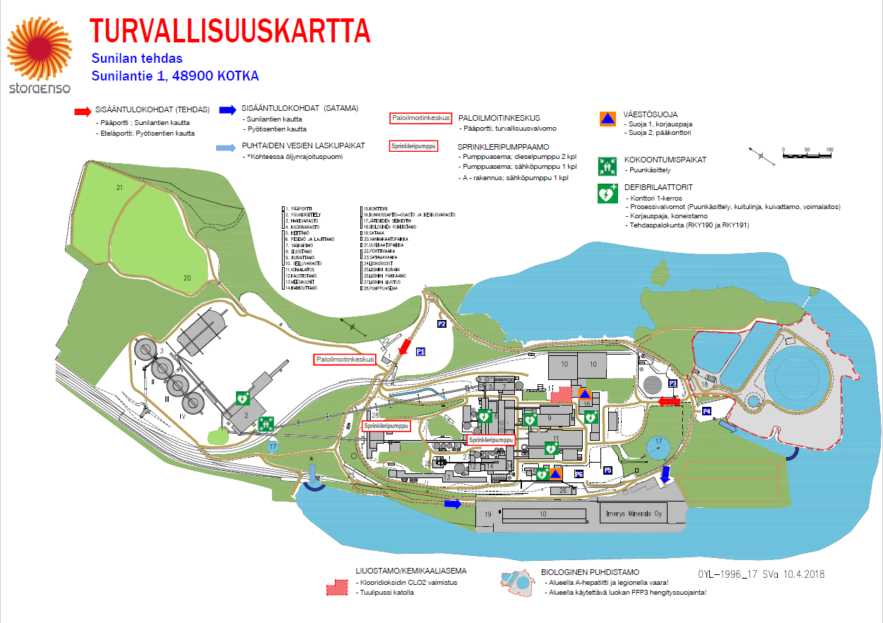

Instructions for safe passage to the canteen
Vehicles may not be used for visits to the canteen. The parking facilities at the mill are very limited and improper parking hinders traffic and creates danger by creating roadblocks. A plan has been made in advance for the parking spaces used by the contractors, which must be followed. Pedestrian routes must be kept safe.

General hazards of the construction site
Shutdown construction site area will be demarcated from general traffic, but construction site traffic will have to be allowed in the area. The biggest dangers that suppliers should pay attention to in their own HSE plans are described below.

Dangers and risks related to implementation
- Corona epidemic.
- Exposure to chemicals, steam, pressure, ionizing radiation, hydraulics, electricity, hot mass/water or biological agents, e.g. Chlorine Dioxide, Hydrogen Sulfide and Legionella bacteria.
- Soil excavation work and work machines. Burial in a trench, wood chip silo, etc.
- Risk of falling from a height.
- Traffic on the construction site and the construction site in the area.
- Access by outsiders exposed to work hazards.
- Lifts in the area, unloading and loading of goods and transfers from the transport vehicle.
- Demolition of structures, structural parts or materials.
- Jobs that involve assembling or disassembling heavy prefabricated parts.
- Heavy or demanding lifting.
- Ensuring the bearing capacity of the soil when using vehicle lifts.
- Unevenness of the construction site area.
- Construction waste and extra supplies at the construction site.
- Several different nationalities, so cooperation can be challenging when communicating.
- Machines in operation

Measures that improve occupational safety and working conditions
- Compliance with COVID-19 guidelines:
  - Employees of suppliers coming to Sunila's shutdown can be given a self-administered rapid COVID-19 test as part of the issuance of a travel permit upon arrival at the mill.
  - Compliance with hand hygiene, use of a face mask, safety intervals, compliance with work permit instructions. For work permit matters, you may not visit control rooms, but must do business at the work permit points guided by the work permit preparers.
- Scheduling and coordinating the work in the downtime plan. Written HSE work plans, written work permit with risk assessments in all work phases, reporting the completion of the work with the signature of the work permit in connection with the return of the work permit.
- Before starting work, employees must familiarize themselves with the emergency exit routes of their workplaces and the location of the fire alarm buttons, first extinguishing equipment and emergency and eye showers so that they can be found quickly if necessary.
- Workgroups must always carry out a risk assessment of their own work before starting work. Working on different floors on top of each other must be taken into account in the risk assessments, no member of one's own or other work groups must be under a load or exposed to falling objects or other things. Danger areas must be fenced off and signposted. If the conditions change substantially, the conditions for safe work must be reassessed with the work supervisor (/customer).
- Zero-Energy-Tila, i.e. NET measures, including locking and closing, are carried out in accordance with Sunila's process equipment safety instructions to avoid exposure to process hazards. Note! Contractors must install their own lock on the safety switch to ensure the prevention of accidental starting of pumps, conveyors, mixers, etc. equipment during their own work.
- Protective equipment according to the requirements of the Sunila mill, incl. always in outdoor areas highly visible clothing (EN ISO 20471 class 2), use and use of additional protective equipment according to the job-specific risk assessment.
- Orientation and guidance for those working in the area, incl. familiarization with the use of the mill's bridge cranes. Comprehensive security training material. Every employee who comes to a shutdown completes the necessary training, such as the shutdown info, which is a prerequisite for issuing a pass. Contractors are responsible for familiarizing their staff with the work task and the job itself.
- Site map and isolation of the site and marking of alternative routes.
- Those using personal lifts must have written permission from the employer and an inspection of the lifts must be carried out and documented before using the lift.
- When erecting or dismantling scaffolding, the area must be isolated so that no one can enter the danger area. In a closed space such as a tank and a boiler, there must not be other work groups during the construction / dismantling of scaffolding.
- Suppliers must always arrange for their employees/subcontractors who speak a language other than Finnish or English to have a Finnish or English-speaking representative at the site, in order to ensure that employees of different nationalities understand safety issues.
- Site inspections and safety tours.
- A culture of safe operation at the shutdown site by guiding and intervening, and as a last resort, sanctions.

Withdrawals and transfers
Downtime Demanding and frequent lifts are carried out on the site, the dangers of which suppliers must pay special attention to in their own HSE plans.

Dangers and risks related to implementation
- Working on multiple levels.
- Delimitation of the lifting area by fencing and signage of the fence.
- Lifts and equipment installations and hauling.
Measures that improve occupational safety and working conditions
- Fall protection always when working at a height of more than 2 m.
- All openings in the floors must be protected and all places where it is possible to drop things must also have skirting boards. (stairs, racks, canopy, etc. levels). Plans regarding fall protection must be made so that nothing can fall to a lower level at any stage of the work. Work performed simultaneously on different levels must be coordinated so that the danger caused by goods falling from above is prevented.
- Access to all areas with a risk of falling must be prevented by making proper handrails. Height at least 1.1 m (at a height of more than 6 m, the railing must be 1.2 m high).
- Racks must be approved for use and all racks must have a rack card and a valid weekly inspection.
- Scaffolding must be built and erected in accordance with Vna 205/2009 and the European SFS-EN scaffolding standards and the RIL 142 instructions for work and protective scaffolding. If the scaffolding cannot be erected perfectly in accordance with the standards, for example, if the scaffolding is approved for use only with fall protection or the scaffolding is built from temporary materials, there must always be an implementation plan and a written work permit for the construction of the scaffolding.
- Lifts must be periodically inspected and used only for the approved purpose. Lift operators must be familiarized/trained and must have a lift operator's license issued by the employer. A daily start-up inspection must be performed on the lift, every time the device is put into use. With installation cranes, the load fixer must have the employer's written permission.
- Work planning and preparation of lifting plans in cooperation with the parties on the site. For particularly heavy or difficult lifts (e.g. 2 cranes), there must be a separate safety supervisor on site.
- Choosing the right tools and methods for the job.
- Construction site logistics planning so that there is no excess stored goods in the area.
- Planning hauling routes in the construction site area

Fire and explosion hazard
Dangers and risks related to implementation
- Fire risk during work, fire load incl. packaging materials.
- Roof fire caused by roof maintenance work
- Deliberate fire caused by vandalism
- Electrical centers, field boxes start a fire
- A vehicle or work machine or lift causes a fire in the construction site or inside the building
Measures that improve occupational safety and working conditions
- The construction site area is kept neat and orderly, and the exits are kept open.
- Hot work permit practice in accordance with Sunila mill instructions. Removal/protection of combustible material within a 10 m radius.
- Smoking areas are clearly marked and instructed. Elsewhere, smoking is punishable.
- Fire-fighting equipment has been placed in the area throughout the construction site and personnel have been instructed in their use.
- Construction site vehicles must be in good condition and have fire-fighting equipment and systems, if necessary.
- Vehicles must be stored in the places assigned to them.

Dust, noise, vibration
Dangers and risks related to implementation
- There is noise on the construction site, and there are exceptional noise situations in the construction site area, especially during shutdowns.
- Vibration for existing structures and equipment.
- Dust in tasks at work.
Measures that improve occupational safety and working conditions
- Work methods must be chosen in advance in work planning and, if necessary, personnel must be warned about temporary noise if the danger cannot be eliminated.
- In the construction site area, where the noise level momentarily exceeds 100 dB and the basic level is 85 dB, noise warning signs must be used and hearing protection in that area. Such spaces include all downtime work areas indoors.
- Respiratory protection must be worn when there is a risk of small particles or dust in the construction site area.
- Taking care of the cleanliness of the construction site.

SAFETY RULES

Safety objectives
The goal is 0 accidents and 0 fires. The purpose is that all those participating in the shutdown get home safely after the workday and can continue working on the site the next day.

Stora Enso's suppliers must draw up an HSE plan and train their own and their subcontractors' personnel in the HSE plan they draw up. Every employee must know how to observe the work environment and recognize dangers and act to eliminate the danger.

Every employee must know their responsibilities in terms of safety and must stop dangerous activities and inform the customer's contact person about this.

Each person must observe the work environment, the goal is one safety observation report / person to the SMART system of the Sunila mill, including subcontractors.

Safety management
At the shutdown site, the provisions of the customer liability and occupational safety legislation, the Sunila mill's instructions and current legislation, as well as good occupational safety practices are followed. These create the basis for the safety rules of the shutdown site and the culture formed from them.

Safety during shutdowns is implemented in cooperation with the organization of the annual shutdown of the Sunila mill and representatives of suppliers and subcontractors. Stora Enso Oyj's Sunila mill is leading the cooperation during downtime.

The task of safety management is to identify and assess work-related and work-related hazards and to prevent the occurrence of accidents and dangerous situations.

The goal will be realized when a good safety culture is formed at the shutdown site. In a good safety culture, everyone is committed to doing things safely and safety is always a priority.

The attitude of safe working is introduced to every employee on the construction site by monitoring and committing suppliers to safe operation through their own HSE plans. The HSE plan is a plan drawn up by the supplier for carrying out the scope of the contract safely and for coordinating the work with other suppliers and the operation of the mill in compliance with the rules and procedures of this safety document.

The implementation of the HSE plans is monitored by regular safety rounds and continuous supervision at the site. Supervision is carried out by the suppliers' work management and the mill's installation supervision, as well as department-specific persons appointed to monitor safety. All must immediately address deviations.

Shutdown safety control procedure
- Safety rules and procedure instructions
  - The supplier's HSE plan by department/job
  - Safe work plan in compliance with rules and instructions
  - The customer's supervisor and the supplier draw up the work permit together and assess the risks and protection against them
  - The person in charge of the area checks and issues the work permit
  - The work groups are obliged to carry out a risk assessment of their own work every day before the start of work and after breaks, when the conditions at the work site have changed. The work permit must be updated when circumstances or employees change.

Special focus areas for downtime safety
1. Induction
- Orientations completed and confirmed during downtime.
- Safety briefings must be done well in advance of the start of the shutdown. Access permits must be checked in time before the employees arrive at the mill, so that any deficiencies can be communicated to the subcontractor for correction and there will be no unnecessary delays in issuing the access permit at the gate.

2. Communication
- When working on a construction site, each supplier and their subcontractor company must have a Finnish-speaking representative on the construction site.

3. Scaffolding safety
- Scaffolding work is planned in advance, and side by side and overlapping work must be taken into account in implementations and changes. The customer acquires a separate rack inspector.

4. Hearing protection at a shutdown site
- Use of hearing protection and instructions in downtime work areas. Communicate about the use of hearing protection and supervise especially during shutdown safety rounds.

5. Chemical safety at the construction site
- The security measures must have been taken and a work permit drawn up, which prescribes the necessary precautions.
- The suppliers must have a list of the chemicals used on the site and Safety Data Sheets and, if necessary, reserve a safety pool for the chemicals, such as e.g. for fuel tanks/drums.

Eight life-saving rules
Stora Enso has introduced 8 life-saving rules that everyone must follow 100 percent.
- Always wear a seat belt in the vehicle.
- Never exceed speed limits or use a mobile phone without a hands-free device while driving.
- Never drive or work under the influence of alcohol or drugs.
- Always remember to have a valid work permit when you need it.
- Always wear personal protective equipment when working at heights.
- Always make sure that the energy supply is isolated before starting work.
- Never bypass or ignore critical safety equipment.
- Do not walk or stand near a moving machine in use.

Subscriber security monitoring
The safety coordinator appointed by the mill directs and instructs the parties of the work site to work safely in the construction project in accordance with this safety document. The safety coordinator acts as a promoter of cooperation and ensures, together with the person in charge of the site, that safety rounds and regular inspections are carried out on the site.

The organization of the annual shutdown of the Sunila mill, the installation supervisors of the suppliers and the safety supervisors of the shutdown must deal with all dangerous situations, dangerous places and deficiencies in safety on the site. They have the right to give direct orders to the work performers to correct safety-related deficiencies, and the right to interrupt the work. All deviations must be reported to the installation supervisors.

All safety findings and events are recorded in the Sunila mill's SMART system. Installation supervisors are responsible for recording safety observations, dangerous situations and accidents in the system, as well as incident investigation and reporting in accordance with Sunila mill instructions. After approval of the right of way, a so-called SMART link, from which you can directly make safety announcements.

Serious dangerous situations and accidents are reported IMMEDIATELY to the work supervisor and the manager of the Sunila mill, as well as the occupational health and safety manager.

Stora Enso, the shutdown and the mill management monitor the shutdown safety situation and the safety of the site during the shutdown site meetings through safety rounds and safety announcements.

The safety statistics of the shutdown site are not kept separately, but the safety statistics of the site are included in Stora Enso's safety statistics. Safety events during the shutdown, such as accidents, dangerous situations and fires, as well as safety observation and safety behavior, are monitored in the shutdown meetings held during the shutdown.

During the shutdown, firework audits are carried out by the site supervision, the feedback from the firework audits is discussed at the shutdown site meetings.

Responsibility when ordering external labor
Stora Enso operates responsibly every day and requires the same responsibility from all actors in its supply chain. Below is a list of things that must be ensured when ordering external construction and installation labor for the mill.

Stora Enso must monitor that the use of labor is legal. The condition for this is that the various actors in the subcontracting chain, such as the customer, main contractor and suppliers, as well as subcontractors, have been defined in contracts. In addition, it must be ensured that

- All entrepreneurs in the subcontracting chain either have a Y ID or, if the question is a foreign company, a copy of the power of attorney must be available to the company's representative in Finland.
- Foreigners working at the mill must have written evidence of the right to work in Finland.
  - Citizens of EU and EEA countries must have a copy of a travel document, such as a passport or identity card
  - For citizens of other countries, a copy of the travel document, work/residence permit and possibly a copy of the visa
- Employees from EU and EEA countries must present A1/E101 forms or a certificate from Finnish pension and social security.
- All employees must be insured against accidents. The insurance must be valid for work performed in Finland.
- In addition, all external employees must provide a copy of the identity card in accordance with the requirements of construction sites and be able to prove their identity at any time.
There are separate instructions on the identification and identification of persons, as well as the required occupational safety and fire work qualifications, which must be followed on the site.

All subscriber responsibility documents must be delivered to the subscriber in an understandable language via the Zeroni system, either in Finnish or English.

Operations of the mill and suppliers
Stora Enso must take care of the division of tasks between different employers and self-employed workers, as well as cooperation in preventing dangers that threaten the safety and health of employees and in informing about possible dangers. In addition, the organization of the annual shutdown of the Sunila mill must ensure that the work can be done safely and without causing harm to the employees' health, and that the different work phases are properly timed.

Responsibilities of suppliers
Suppliers and subcontractors must appoint a responsible person on the site before starting the work, who will guide the activities of their subcontractors by scheduling and coordinating the work phases.

The person in charge of the suppliers and subcontractors must take care of the general management of the construction site necessary for safety and health, and the organization of cooperation and information flow between the parties, the coordination of activities, and the general cleanliness and order of the construction site area. The person is also responsible for organizing cooperation and information flow, as well as informing about workplace hazards. A deputy must also be named for the responsible person.

Suppliers and subcontractors must provide the customer's representative with a list of the project's responsible and contact persons with contact information before starting the work and update the list during the work.

Suppliers and subcontractors responsibilities include:

- to draw up a written HSE plan for site cooperation
- participate in safety cooperation at the construction site and in safety and construction site meetings
- supervise the making of a written hazard assessment at the site using the SMART application
- monitor compliance with the required safety instructions and rules at the site
- a separate HSE supervisor present at the site must be assigned to the site, if the combined personnel strength of the supplier's own and subcontractors on the site during the entire site (e.g. annual maintenance shutdown) is more than 50 people.
  - The minimum requirement for an HSE supervisor:
    - takes care of the safety expertise of the supplier and the subcontractors it uses at the site, so that the personnel knows the HSE plan drawn up by the supplier and the customer's/mill's safety instructions related to the work
    - monitors compliance with the HSE plan and customer/mill instructions, as well as the safety of the work environment, work methods and work tools by intervening and providing guidance
    - participates in the safety rounds organized at the construction site and, if necessary, in construction site meetings
    - reports on detected deviations and related measures
    - in close-up and accident cases, measures are taken to investigate the incident and measures to avoid similar damage​
    - works in cooperation with the customer's contact person and the mill's safety organization
The supplier must limit the chaining of subcontracts arriving at the site to a maximum of two levels. The supplier must notify and approve its subcontractors with the customer well in advance of the downtime in accordance with the instructions given locally in the Zeroni system.

Security planning, which is the responsibility of suppliers
Suppliers must make written HSE plans for work safety before starting work. It is the suppliers' responsibility to ensure that the plans have been approved by the representative of the Stora Enso Sunila mill's annual shutdown organization. The HSE plan is approved and saved by the work orderer/installation supervisor in the Teams electronic downtime folder.

The HSE plan is made based on the customer's form base, which takes into account the danger of the site and the work site, as well as the rules at the site, which the supplier responds to with the HSE plan. The basic structure is that at the beginning of the plan, the supplier prepares the company's basic information and instructions for working on the site. In addition, each job site must have its own job description and response to hazards.

The supplier has the obligation to update the HSE plan if there are changes in the execution of the work. The different work phases and their timing must be organized in such a way that they do not cause danger to those working on the site or to others affected by the work. The HSE plan must be revised as circumstances change.

Also, every contractor working on a construction site must prepare written plans for dangerous work and work phases before starting work. The work is allowed to start after the representative of the Stora Enso Sunila mill's annual shutdown organization has approved the plans and issued a work permit and a copy of the work permit has been delivered to the department's control room via the work permit point.

The supplier replies that it is clear to every employee where the site instructions (ie Millinfo, Sunila) can be found in the SMART application and the employee knows how to use it. The customer sends a link to each approved worker via text message, through which the site instructions can be accessed. If necessary, the key safety issues of the info are printed out for the employee in paper form.

Acceptance criteria for the supplier's HSE plan
In the suppliers' written work safety HSE plan, it must be stated how the supplier implements the familiarization of its own and subcontractor's personnel to the rules of the construction site and safe working on the construction site, as well as the supervision and safety monitoring of the work.

The rules and procedures specified in the safety document must be included by the supplier in the HSE plan, and the plan must include:

- WORKING LAND BASIC INFORMATION
  - Description of the contracting object or objects
  - Basic information and contact information of the customer and the installation supervisor
  - The supplier's and subcontractors' own occupational health and safety organization

- GENERAL SAFETY RULES AND INSTRUCTIONS AND ACTIONS
  - Management of employee qualifications
  - Use of personal protective equipment and requirements at the construction site
  - Life-saving rules and actions
  - Safe use of hand tools and inspections and training
  - Site traffic and storage and transfers of goods and materials
  - Demarcation and marking of the construction site
  - Fire safety at the construction site
  - Management of deviation situations
  - Safety cooperation with other contractors and the mill
  - Procedures in the event of an accident or accident
  - First aid and initial extinguishing readiness
- ORGANIZATION AND CLEANLINESS IN THE WORKPLACE
  - Cleanliness and order of work sites
  - Environmental matters and sorting
- STAFF TRAINING
  - Orientation and basic qualification training for employees and supervision
  - Operating model for orientation to the job
- WORKPLACE SAFETY PLANNING AND MONITORING
  - Rules for coordinating work and ensuring information flow
  - Site maintenance inspections and daily inspections
  - Ensuring the working condition of machines and equipment
  - Safety deviation monitoring and communication to the mill.
- HAZARD IDENTIFICATION AND RISK MANAGEMENT
  - Identification of hazards from contract work and risk management measures
- WORKING, LIFTING AND SAFETY PLANS
  - Plans drawn up for work sites

Responsibilities in safety monitoring
Stora Enso is responsible for the inspections mentioned in Vna 205/2009 being carried out at the site. The suppliers and their responsible persons are responsible for making use of the inspections and for correcting the deficiencies and defects revealed during the inspections.

The organization and suppliers of the annual shutdown of the Sunila mill must ensure that:

- all inspections required by regulations are carried out on time and carefully.
- the inspectors have the necessary professional skills.
- appropriate protocols are drawn up for the inspections.
- defects found in the inspections endangering work safety are corrected immediately.
- for other deficiencies, a deadline is given to make corrections and a person responsible for it is named.

At the construction site, during the work, at least once a week, in the maintenance inspections, e.g. general arrangement of the construction site and work sites, electrification during work, lighting, lifting equipment, lifting aids, milling and sawing equipment, walkways. In addition, other matters important from the point of view of safety must also be checked. In the inspections, attention must also be paid to the fact that the construction work coordination measures referred to in Vna 205/2009 § 13 are handled in a timely manner.

In addition, Stora Enso and the suppliers must ensure that the access, exit and traffic arrangements of the construction site are checked in connection with the weekly inspections of the construction site and regularly every day as normal inspections.

Stora Enso has the right to participate in all the suppliers' own inspections on the site or, if necessary, carry out occupational safety inspections and inspections and investigations related to occupational health care at the workplace itself.

Suppliers must have inspection protocols and written hazard identification forms or their copies of all inspections and hazard identifications performed at the site. Inspection records must be kept at the site and must be presented to Stora Enso's representative upon request.

The inspection protocols are also submitted for information to the mill's installation supervisors. Stora Enso's representative can define the protocol base to be used on a case-by-case basis.

Stora Enso takes care of the general cleanliness and order of the construction site, e.g. in the following ways:

- by planning the use of the construction site
- by providing guidance on the responsibilities of the various parties in maintaining cleanliness and order
- by taking care of fire prevention and initial extinguishing and other protection equipment
Suppliers must immediately report accidents, dangerous situations and environmental damage situations that have occurred in the project to their installation supervisor. The installation supervisor reports these to the person in charge of the site and the safety coordinator and, if necessary, to the occupational safety and health authorities, and participates in the investigation of the cases together with the promoters of the mill.

Employees must follow the given safety instructions and use the necessary protective equipment, remove the dangerous situations they observe and report them, also report if they cannot remove the danger themselves. Protective devices, instruction or warning markings may not be removed or switched off without permission. The employee has the right to refrain from unsafe work.

Stora Enso must be reported on the implementation of improvement and corrective actions brought up in the investigation and their impact on safety.

Meeting practices
In the supplier-specific site start-up meeting or a separate occupational safety meeting, the key hazards and safety issues related to the site and work, as well as the HSE plan drawn up by the supplier, are reviewed.

The construction site organizes a safety and construction site meeting on weekdays, every day during downtime. Open-time meetings are held at separately agreed times. The safety tour memo and deviations are stored in the SMART system.

In all installation and site meetings, issues related to site safety must be on the agenda. In the safety section of the site meeting, all the safety events of the previous section must be reviewed; accidents, dangerous situations, observations.

The representatives or supervisors of those currently working on the site, suppliers and subcontractors must be present at the safety and site meetings.

Staff orientation, qualifications and IDs
Stora Enso requires that all those working on the site have participated in the required trainings online, such as Stora Enso's general safety information, Sunila mill's local safety information and SUNILA's Shutdown Safety Information. Everyone working in the area must have a valid work safety card in accordance with the mill's instructions.

At the Sunila mill, those involved in fire work must have fire work training in accordance with the training program approved by the Finnish rescue industry central organization.

Suppliers must ensure that their own personnel and other subcontractors as well as independent work performers are knowledgeable about shock site safety information. Everyone must know the site's safety rules and procedures. The installation supervisor of the work ensures that the regulations and instructions related to safety are passed on to all contractors and independent work performers.

Stora Enso and suppliers must ensure that all employees at the workplace have received the necessary information and instructions about the hazards and harmful factors affecting the work. Each contractor is responsible for familiarizing his own employees with the construction site and its conditions, as well as the tasks and working conditions.

The orientation given must be documented. Up-to-date information on orientation and persons with the aforementioned qualifications is available for viewing in Zeronii.

Stora Enso and suppliers must ensure that every person working on a construction site has a unique photo ID card that meets the requirements of the construction site. The identification must show whether the person working on the site is an employee with an employment relationship or an independent contractor. The employee's identification must include the employer's name (payer) and tax number. Everyone working on the construction site must be registered in the public tax number register.

Each contractor must provide Stora Enso with the information of its own employees and those of its subcontractors working on the site before starting the construction site to ensure the correctness of the labor law.

Stora Enso and suppliers must ensure that all employees have a valid right of access to the area.

Suppliers must familiarize all persons coming to the site with the supplier's detailed HSE plan prepared for shutdown work, which has been approved by Stora Enso. Everyone must follow the safety instructions in it. If the instructions are violated, we act in accordance with the site's sanction rules.

PROCEDURAL INSTRUCTIONS

WORKING
To work in Stora Enso's mill area, a valid right of access to the area and job-specific safety training are required.

A written work permit is ALWAYS required for work.

When the work is finished, the final cleaning must be done and the work permit must be signed at the work permit point.

Employees must make a risk assessment for their work permit using the SMART application every day or when conditions change significantly.

All the time you are working, you must use the protective equipment prescribed in advance and required due to the risks of the work!

Everyone entering the mill area must pass through the gate, where they will be identified and recorded as having entered the area. If necessary, a site-specific personnel list can be run from the access control system, which shows the name of the company, number of personnel, contact person and phone number.

Personal protective equipment
When working in the mill area of Stora Enso's Sunila mill, the basic personal protective equipment is always a helmet with a chin strap, goggles or a visor, safety shoes, and clothing that is always highly visible in the outdoor area.

In particular, the following must be taken into account:
- Protective gloves suitable for the job must be used in all physical work. If there is a risk of cuts or punctures at work, cut-resistant gloves must be worn.
- The chin strap of the helmet must be attached and a helmet welding mask must be worn during welding work.
- If there is a risk of chemical spills or dust at work, you must use protection according to the safety instructions and tight goggles!
Other personal protective equipment must be used based on the work permit and work risk assessments. The need for protective equipment must be assessed for each job, taking into account the working conditions. If an exception is needed for the use of protective equipment, it must be recorded in the written work permit.

When used, the protector must be in a condition according to the manufacturer's approval, and a visual commissioning inspection must be performed every time it is put into use.

It is the responsibility of all parties to monitor that the protective equipment is used in accordance with safety regulations and instructions.

Contractors must obtain the necessary protective equipment for their employees. The protectors must be in accordance with the requirements, suitable for the purpose and suitable for the user. Protectors are always personal. (Government decision on the selection and use of personal protective equipment at work 22 December 1993/1407 § 3)

Noisy work
If the work causes noise in the environment, Stora Enso must take care of the notification obligation according to Section 60 of the Environmental Protection Act, regarding temporary activities that cause particularly disturbing noise. In addition, environmental protection regulations must be followed

Tools and machines and equipment
The work tools and equipment and machines used on the construction site and at work must be appropriate and of sufficiently strong construction for the conditions of the construction work at different times of the year. They must meet the requirements set for occupational safety and must be protected in such a way that they do not pose a danger to their users or others on the site. If necessary, they must be equipped with auxiliary devices that do not cause damage to the materials to be processed, the finished work piece or the environment.

When using a tower, vehicle or loading crane, you must always ensure that the floor or soil is sufficiently load-bearing and level. All cranes over 25 tonne meters require an erection permit and a written lifting plan.

Machines and equipment and work tools arriving at the construction site must be inspected to ensure the condition of the equipment and the operation of the required safety devices, as well as the validity of periodic inspections. The inspection must be marked on the machine.

Commissioning inspections must be done in writing for work platforms, lifting devices and similar equipment. In addition, the inspections include maintenance inspections during operation and a daily commissioning inspection, which must be recorded in the device's inspection folder or something similar.

The condition of lifting aids must be monitored especially on the construction site. The approval and inspection of the lifting aid must be valid and it must always undergo a visual commissioning inspection before use.

Combustion engine-powered machines must have a cleaning and maintenance program, and the machine must always have at least one 27A 144BC class hand fire extinguisher fixed in a visible place.

Any detected defects in the device or deviations in cleanliness or safety devices must be corrected immediately. A faulty and untidy device must be disabled until the deviation is corrected. The prohibited device must have a visible warning sign so that the prohibited use can be detected by all users

CONSTRUCTION AREA

Work areas
Stora Enso is responsible for drawing up the overall site plan, and suppliers and subcontractors must match their own site plans to this plan.

In cooperation with the installation supervisor, the supplier must draw up a site plan and the associated work-time organization plan for the site area and submit them for Stora Enso's approval.

The construction site plan must present the protection and marking measures for the construction site and the workplace. They must be planned and implemented in such a way that the safety of those working on the site and the safety of those outside the site are ensured. Hazards must be identified in the planning of work areas and the work site areas must be demarcated accordingly.

Plastic construction site fences have been purchased for individual construction site demarcations, which should be used to delimit work stations and lifting areas. Accidental access of a person to the limited lifting area must be prevented.

The creator of the demarcation must place a sign near the demarcation showing the author of the demarcation and contact information.

Fire safety and fire works
Everyone working on the construction site is obliged to pay attention to fire safety, to act in such a way that there is no risk of fire, and to follow the fire safety instructions prepared separately on the construction site.

Construction waste and other combustible material must be removed from work sites regularly so that the fire load does not become too large.

The placement of flammable liquids must be agreed with the installation supervisors and the mill fire department.

It is forbidden to make an open fire in the construction site and mill area. Smoking is only allowed in designated smoking areas.

All fire work must follow the Sunila mill's fire work permit procedure. In the entire mill area, the hot work plan of the Sunila mill must be followed.

Fire work at a temporary fire workplace and roof and waterproofing works ALWAYS require a written fire work permit.

All hot work parties are required to have a valid hot work card training.

Before issuing a hot work permit, an investigation and assessment of the dangers caused by hot work must be carried out at the hot work site. Hazard statement
and the measures and protections determined on the basis of the assessment are verified before signing the temporary work permit.

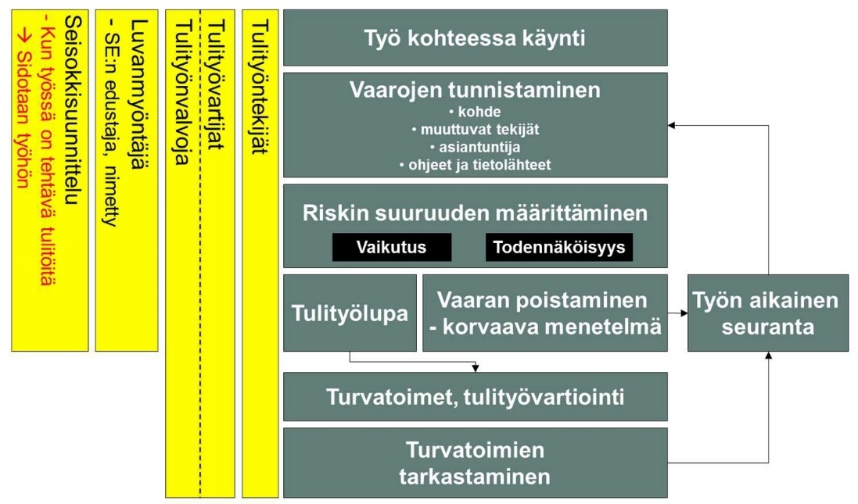

If the work methods or conditions change during the fire work, all parties to the fire work are obliged to stop the fire work immediately and notify the permit issuer of the changes. If the situation allows, after the hazard investigations and assessment, the hot work permit is re-issued to reflect the changed circumstances.

The hot work permit is specific to the hot workplace. The issuer of the hot work permit must go through the safety matters recorded in the hot work permit with the hot work supervisor and the hot worker and the hot work guard before starting the hot work. The issuer of the hot work permit is responsible for ensuring that the safety measures at the hot workplace are sufficient throughout the work and that protective measures have been taken before starting the work in an area of at least 10 m.

After the end of the firework, the firework guard must be continued for at least one (1) hour, which requires the firework guard's continuous presence and keeping an eye on the work site. The fire watch must be continued without interruption even during breaks. After the end of the fire work watch, the object must be observed for (3) hours. Monitoring can be carried out technically or with regular inspection rounds.

Fire safety equipment disconnection request
All those working in the area of the Sunila mill are obliged to notify the equipment manager of the need to disconnect before starting work or activities that may cause the fire safety equipment to operate. If necessary, the equipment manager will assist in determining the need.

The on-duty team leader of the mill fire department is the equipment manager of the Sunila mill's fire detector.

Jobs with a risk of falling

Working at height means working at any place where the worker's feet are 2 meters above a nearby surface and where there is a risk of falling. The danger of falling can also be caused by, for example, a trench, a lifting opening, or when there is
working less than 2 m from the edge of the roof.

In the construction site area, unintentional access to the area with a risk of falling must be prevented by a fixed railing, fence or other obstacle that can withstand a person leaning on it, and by a safety distance. If the railings block the passage, a detour must be indicated, if dismantled
permanent structures, protection must be provided. Temporary protective structures: railings, gratings and other floors, stairs, protective covers, etc. are critical safety equipment that must be marked and secured so that they cannot be dismantled without tools. All openings in floors where employees or outsiders or goods may fall must be protected by a cover or railing. For falling objects or tools, railings and countertops must be fitted with kick strips to prevent things from falling and, if necessary, nets for falling objects. Critical safety equipment must be marked with a sign if the destination does not have a security guard present at all times. The adequacy of critical safety equipment must be ensured by regular inspections. Only the employees who have set the boundary are allowed in the restricted area. Boundary markings may only be removed with the permission of the contact person of the marking.

Going into a fall-risk area without a fall protection harness is prohibited, and when working in a fall-risk area, a written hazard identification and risk assessment must always be carried out, and measures to reduce and/or prevent the risk of falling must be planned before starting work. Safety harnesses and the safety grips and safety ropes used to attach them are used in areas where fall protection cannot be implemented with railings. If the hook of the fall protection harness has to be moved high to a new position due to movement, two hooks must be used, at least one of which must always be attached high up

Working in the lifting baskets of personal lifts requires the use of a fall protection harness, the safety rope of the protector must be attached and the length of the safety rope must be suitable for the purpose. Fall protection devices must be inspected annually by an authorized inspector (VNA 403 / 2008).

Stora Enso is responsible for and monitors that fall protection is implemented at the site in accordance with the requirements and instructions of Section 28 of Vna 205/2009.

Work with a risk of electrical accidents
In the construction site area, special care must be taken when moving construction site electricity. In the areas of passageways and roadways, the cables must be protected from friction caused by vehicles and mobile equipment or be raised sufficiently high. Cables and worksite distribution centers must be placed in such a way that they do not break, get wet, and do not cause a risk of electric shock or a tripping hazard in the work area or on access roads.

If there are uninsulated cables on or near the construction site that cannot be moved or de-energized during the work, they must be insulated with protective structures, etc., to prevent the risk of electrical accidents.

The safety and performance of electrical work is regulated in the Electrical Safety Act 410/1996 and the regulations issued pursuant to it. When live electrical substations, switchgear or transformers and other live devices are put into use on the construction site, the first time the voltage is connected, there is a confirmation of the safety of the connection circuit, and from then on, the electrical safety agreement form is used as a work permit for live sites. In addition, live spaces must be locked with Sunila mill's electrical space lock. Only persons who have received electrical safety training SFS6002 may have access to the premises.

When working in the vicinity of high-voltage lines or the like, the dangers posed by the conditions must be taken into account and the risk of electrical accidents must be prevented.

Preventing the spread of dust
In order to prevent the spread of construction site dust, valid regulations must be followed, for example, regarding asbestos and quartz dust containing crystalline silica (boiler fluidized bed sand).

On the construction site, in cooperation with all parties, the cleanliness of the working air on the construction site must be taken care of, and breathing and eye protection must be used when working where clean working air cannot be guaranteed. Stora Enso is leading the cooperation at the site.

Special attention must be paid to the prevention of construction site dust. Dusting on the construction site can be reduced by dust binding the access roads and quick removal of dust and dirt that has drifted into the environment, watering the aggregates used and covering individual storage piles.

  - TRANSPORT

    - Traffic arrangements and vehicle right of way
Routes leading to the construction site area must be planned and all temporary traffic arrangements must be communicated in advance to the construction site and mill personnel. All temporary traffic arrangements must be approved by Stora Enso.

In the construction site, the passageways for vehicles must be clearly marked with signs and signs. If you have to
to close, for example, during lifting, this must be reported to the on-duty team leader of the mill fire brigade.

The fence and signs delimiting the construction site or site prevent other traffic and people from entering the construction site. This reduces the danger factors caused to those outside the construction site and facilitates control of the construction site.

There is a 30 km/h zone restriction in the mill area. Sanctions follow the site's sanctioning rules.

As a rule, driving to the construction site takes place through the Main Gate. A personal vehicle access permit is granted to a person after a separate assessment in the access right process.

    - Parking spaces
Vehicle traffic on the construction site must be minimized and only mandatory construction site traffic is allowed. For vehicles coming to the construction site, in addition to the existing parking areas, the necessary additional parking areas will be arranged along Sunilantie and Muukanniemi. All vehicles must be parked in the parking areas, excluding unloading and loading of goods deliveries.

Stora Enso is not responsible for any damage that may occur in the mill area, parking area or construction site.

    - Movement in the dispatch office
Unauthorized persons are prohibited from entering the embassy. The depot is in production use and there are forklifts in the area. If there is a need to move to the area of the dispatch office, the movement must be agreed with the employees of the dispatch office.

You may not move around the embassy without permission:
- Registration always first for forklift drivers.
- If you need to bring goods / drive through with a car, work machine, etc., you must ask permission first.
There are no safe/marked walking routes in the embassy:
- Personal beepers must be used at the post office, which alert both the forklift driver and the person in order to stop movement and avoid injury.
- Visibility from the forklifts is very limited and the forklifts have to reverse a lot, so the so-called there are many blind spots.
- You must make sure by saying hello that the forklift driver has noticed you before moving.

  - ORGANIZATION AND STORAGE

    - Sanitation of the environment and construction site
Every supplier is responsible for keeping the environment clean as a result of their work. The work must be organized in such a way that there are no unnecessary adverse effects on people's health and the environment caused by contamination.

The supplier has the obligation to keep the construction site clean and sanitary by removing the dirt, garbage and loose objects that have accumulated there.

- The work environment must be kept orderly and clean at all times, access paths must not be blocked with installation goods or tools, unless separately agreed with the customer.
- Tools and other property must be locked.
- Each contractor is obliged to immediately deliver the scraps they unload and the waste they cause to the scrap and waste pallets using their own equipment.
- Additional pallets are available if necessary, contact the installation supervisor.

Waste must be sorted:

Waste sorted by place of origin:
- bio waste
- waste paper and cardboard
- scrap metal
- energy waste (=burnable mixed waste)
- glass
- dangerous waste

Process waste:
- shell waste
- electric filter ash from a shell boiler, i.e. fly ash
- sludges (bio, fiber clarifier and shell clarifier sludge)
- soda ash,
- lime waste
- the bottom sand of the shell boiler, i.e. the grate sand

Colors of waste containers:
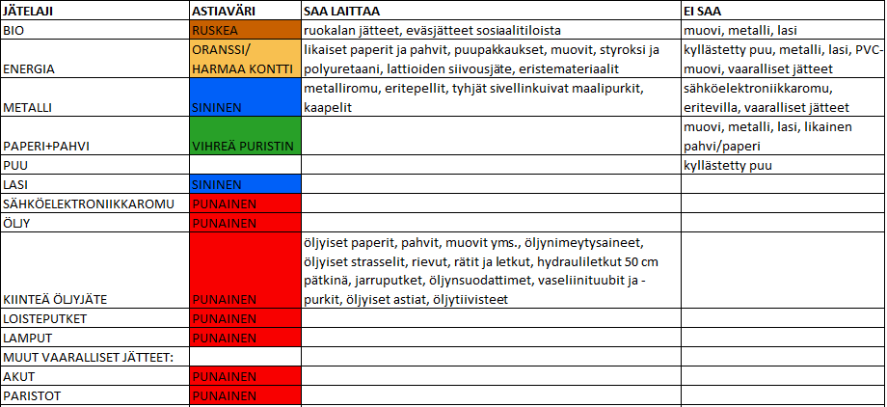

    - Substances and materials harmful to health and the environment
When working with and handling substances hazardous to health and the environment, suppliers and its subcontractors must follow the instructions given by the authorities and make the required notifications in cooperation with Stora Enso.

    - Storage of fuels and chemicals at the construction site
The storage of fuels and chemicals on the construction site must be agreed with the installation supervisor and storage must be kept to a minimum, and the storage location must be fireproof and environmental safety must be taken into account. Oil and chemical leaks into the environment must be prevented by equipping fuel and other tanks with containment basins.

In the storage and use of oils and chemicals, valid legislation and the instructions of the Sunila mill must be taken into account.

    - Chemicals used in work
All suppliers must list the trade names of the chemicals used at work and during the work, as well as the chemical-containing products, and deliver the chemicals' Safety Data Sheets to the chemical handling and storage supervisor responsible for the mill department, whose duty is to ensure that the Safety Data Sheets for the chemicals used on the site can be found at the site.

The Safety Data Sheets for production and maintenance chemicals obtained by Stora Enso can be found in Stora Enso Eco Online's Chemical Manager system. A printout of the safety data sheet can be obtained from the control room of the relevant production department.

    - Other chemicals
In addition, many other chemicals are used in the mill area, where the dangers are mainly site-specific. When working near chemicals, you must be familiar with the dangers of the chemical in question and the safety data sheet.

ACTION IN ACCIDENT AND DANGER SITUATIONS
Anyone who notices or learns that a fire has broken out or another accident has occurred or is threatening and cannot immediately extinguish the fire or combat the danger, is obliged to immediately notify those in danger and make an EMERGENCY ANNOUNCEMENT and to undertake rescue operations to the best of their ability (Rescue Act).

Making an emergency report
Urgent emergency reports are always made without delay without a separate order to the general emergency number 112.

When you make an emergency report:

- Tell me your name and where are you calling from? (The address of the mill is KOTKA, Stora Enso Sunila mill, Sunilantie 1)
- Tell me what happened?
- Tell me where it happened?
- Tell me are people in danger?
DO NOT HANG UP UNTIL YOU GET PERMISSION!

- Follow the instructions you received!
- Organize guidance to the main gate of the mill, to the front door of the target building, and from there to the destination.
Remember: If the emergency number 112 does not answer immediately, you are still in the queue, Do not hang up!

- Report the incident to the mill shift foreman, tel. 050 5298 325.
- Call the general emergency number 112 if the situation changes significantly!

Fire
- Save yourself and the people in danger,
- Extinguish with the nearest fire extinguisher if it is safe to do so. Do not endanger yourself or others!
- Make an emergency report by calling the general emergency number 112,
- Limit the spread of fire by closing doors, windows and air conditioning,
- Leave the building and warn other people working in the area,
- Guide the fire brigade to the destination
Remember! Do not endanger yourself or other people. Even a small amount of smoke inhaled is life-threatening!

Property exit alarm
- Red or yellow flashing indicator light and buzzer alarm in the mill section.
- Get out of the danger zone immediately.
- Wait for instructions, except if it is a general danger sign, see section 5.5

Fire alarm button
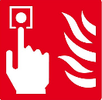
The mill has fire alarm buttons that are connected to the mill's fire alarm system. Fire alarm buttons have been placed at the mill in different spaces, such as office and electrical spaces, as well as in some production departments, for example soda boiler 11 and the lignin dryer.

With the help of fire notification buttons, a person who notices a fire or other accident can quickly report it manually. The fire notification button gives the exact location of the accident to the alarm center, thus speeding up getting help to the scene.

The fire notification button is activated when the button in the middle of the fire notification button is pressed. When the person has pressed the fire alarm button, the indicator light on the fire alarm button lights up, indicating that the alarm has been activated. In some locations, the fire alarm button also activates the area's fire alarms to warn other people of the danger and guide the fire brigade to the destination. After activating the fire notification button, the person must call the general emergency number 112, which can ensure that the alarm goes through and that additional resources can be sent to the target.

First aid equipment and their location
To ensure first aid readiness, the mill has comprehensively placed first aid cabinets. First aid cabinets can be found in the following places:

- Production process inspectors incl. shipping company and lignin packing company ,
- Operating laboratory,
- Bleaching facility,
- central warehouse,
- repair shop,
- The repair facilities of the electrical and automation department,
- car repair shop,
- Wood processing repair facility,
- Power mill repair facility,
- The main gate
The mill has a total of 9 defibrillators, which are placed in the following locations in the mill:

- Process monitors (Wood processing, Fiber line, Drying mill, Power mill)
- 1st floor of the office building,
- Repair shop, record store,
- Dispatch department,
- The mill fire department's lead car RKY190,
- RKY191 fire truck of the mill fire department

Hazard communication
Stora Enso informs everyone in the area of an emergency situation with a general danger sign and/or an SMS text message. The message describes the nature of the emergency and the operating instructions.

When a person enters the mill area through the gate, their phone number is transferred to Stora Enso's alarm system. When the person leaves the area, they are automatically removed from the alarm system.

When receiving an alarm message, you must act in accordance with the given instructions.
- General danger in the mill area
  - Moving to the meeting place immediately, but you must not go into the gas cloud. At the meeting place, you log in to "security" with an RFID access tag. If it is not safe to go to the meeting place, take the safest route out through access control, taking into account the circumstances.
- A fire situation in the mill area or on the construction site
  - Moving to the meeting place when ordered, but you must not go into the gas cloud. At the meeting place, you log in to "security" with an RFID access tag. If it is not safe to go to the meeting place, take the safest route out through access control, taking into account the circumstances.

Upon hearing the sign of general danger, the department's personnel must immediately move indoors to the gathering place.

- Machines and equipment are stopped and the mill is brought down in a controlled manner by the order of the shift foreman, following the department's shutdown procedures.
- Everyone ensures that the work remains in a safe space, after which there is an immediate exit with a gas mask through the upper or side wind to the meeting place of the mill. When leaving the meeting place, make sure that other people working in the department are also informed of the danger and that they can leave the meeting place safely.
- At the meeting place, take shelter inside the building. At the meeting place, you log in to "security" with an RFID access tag.
- If it is not safe to go to the meeting place, take the safest route out of the mill area through access control, taking into account the conditions .
- At the meeting place, follow the instructions given by the meeting place manager. You must not leave the meeting place until permission is given by the meeting place director.
- The main wind direction can be checked from the wind bag on the roof of the chemical station and from the direction of the mill fumes.

The sign is a rising and falling danger sign lasting 1 minute:

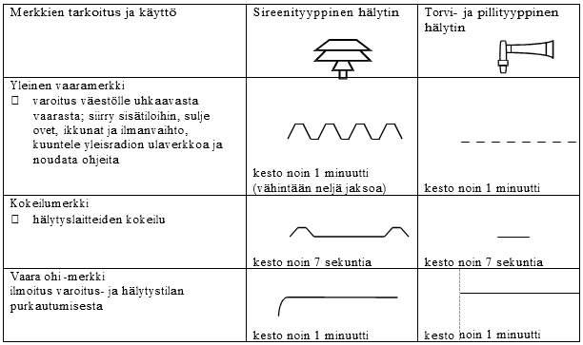

Protection
When the property exit alarms sound, leave the building immediately and report to the department's control room. It is safe for the department to go back to work only after the operating staff has verified the situation and given permission.

The gas danger affecting the entire mill area is notified by the mill's external population alarm. In this case, a general danger signal is given by the population alarm. The population alarm also activates the exit/gas hazard alarms in the buildings.

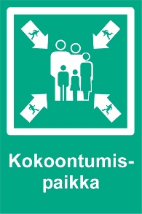
General danger sign
  - Machines and equipment are stopped and the mill is brought down in a controlled manner by the order of the shift foreman, following the department's shutdown procedures.
  - Everyone ensures that the work remains in a safe space, after which there is an immediate exit with a gas mask through the upper or side wind to the meeting place of the mill. When leaving the meeting place, make sure that other people working in the department are also informed of the danger and that they can leave the meeting place safely.
  - At the meeting place, take shelter inside the building. At the meeting place, you log in to "security" with an RFID access tag.
  - If it is not safe to go to the meeting place, take the safest route out of the mill area through access control, taking into account the conditions.
  - At the meeting place, follow the instructions given by the meeting place manager. You must not leave the meeting place until permission is given by the meeting place director.

The main wind direction can be checked from the wind bag on the roof of the chemical station and from the direction of the mill fumes.

SECURITY SANCTIONS

Procedure for safety deviations at a shutdown site
- All employees in the area have received instructions and understand these rules.
- Safety deviations are monitored and dealt with all the time.
- Safety deviations are classified into two groups:
  - Small deviations, jeopardizing safety or not following instructions.
  - Serious deviations, serious endangerment of one's own safety or that of others .
- Deviations are pointed out and the information of the person and the company is recorded in the monitoring system.

Sanctions and procedure
At the downtime site, the procedure is carried out in accordance with the Sunila mill's sanctioning instructions if the safety instructions are violated. Every supervisor makes sure that the employees know the safety requirements and that they have the tools and requirements that are suitable for the working conditions protective equipment and that the employees know how to use and maintain the protective equipment provided. It is the responsibility of the supervisor and management to ensure that personal protective equipment is used. If the person refuses to use the protective equipment assigned to him, he will be removed from the workplace until the matter is corrected. Deviations are handled according to the Fair feedback and treatment model.

Minor deviations:
- The first time, we point out the person.
- At the second time, the person is invited for an interview.
- If even after this the same person receives a notice, that person will be removed from the site for a fixed period (1 week - 1 year) depending on the seriousness of the situation.
- For three breaches of safety, a person can be removed from the site permanently.

Serious security deviations:
- Serious security deviations include e.g. when a person violates Stora Enso's 8 life-saving rules and/or poses a serious danger to himself or another.
  - Work must be stopped immediately and safe continuation of work in the area must be ensured.
  - Work interrupted due to a serious safety violation leads to the immediate removal of the person from the site.
  - Further measures will be initiated together with the supplier's responsible person and supervisor.
- In the event of a serious deviation, the person can be immediately permanently removed from the work site.
- All serious safety violations are investigated, follow-up actions are case-specific and may differ from the actions in this material.
- For serious safety deviations, a separate safety deviation report is always made in writing, which is given to the person and the person's supervisor.
- The measures can also target the company where the person works.
- Serious deviations are reported to procurement functions and the company is complained about by the customer's responsible person in writing. Sanctions are decided by the customer's responsible person together with the occupational health and safety manager of the Sunila mill.

DISCLOSURE

Site communication
The mill manager or his deputy is responsible for information related to operations and organization in the mill area, in accordance with Stora Enso Oyj's instructions. Stora Enso's external communication assists with communication.

The personnel working at the Sunila mill must be informed in advance about the effects of the work and the work site. Stora Enso's internal communication assists with communication.

Communication of dangerous situations and accidents
Dangerous situations and accidents must be communicated in accordance with the Sunila mill's instructions. Immediately notify the safety coordinator, the mill manager and the occupational health and safety manager of the Sunila mill, and any ignition or fire must be immediately reported to the mill fire department on duty, even if there is no need for rescue operations.

Exception communication
Stora Enso's exceptional situation guidelines are followed in exceptional situations that occur on the construction site.

Attachment 1

